H.T No
Regulations:
A18

Sreenidhi Institute of Science and Technology
(An Autonomous Institution)
Code No: 7BC02 Date: 15-July-2021 (AN)

B.Tech I-Year II- Semester External Examination, July-2021 (Supplementary)
ENGINEERING GRAPHICS AND DESIGN (CIVIL, CSE, IT and ECM)

Time: 3 Hours Max.Marks:70

Note: a) No additional answer sheets will be provided.
b) All sub-parts of a question must be answered at one place only, otherwise it will not be valued.
c) Missing data can be assumed suitably.

ANSWER ANY 5 OUT OF 8 QUESTIONS. EACH QUESTION CARRIES 14 MARKS.

Bloom's Cognitive Levels of Learning (BCLL)

Remember | L1 | Apply | L3 | Evaluate | L5
Understand | L2 | Analyze | L4 | Create | L6

 |  |  | BCLL | CO(s) | Marks
1. |  | Construct an ellipse when the distance between the focus and the directrix is 45 mm and the eccentricity 2/3. Also draw normal and tangent to the curve at a point 25 mm from the directrix. | L3 | CO1 | [14M]
2. |  | A line AB 80 mm long has its end A , 15 mm from both HP and VP .The other end is 40 mm above HP and 50 mm infront of VP . Draw the projections of the line and find its inclinations with HP and VP. | L2 | CO2 | [14M]
3. |  | A hexagonal prism, base 40 mm side and axis 90 mm long has an edge of the base parallel to the H.P. and inclined at 30⁰ to the V.P. Its axis makes an angle of 60⁰ with the H.P. Draw its projections. | L4 | CO3 | [14M]
4. |  | A Square pyramid, base 25mm side and axis 65mm long, resting on the ground on its base with a side of the base parallel to V.P. The sectional plane is inclined at 60⁰ to H.P. and cuts the pyramid at the centre of the axis. Draw the development of lateral surface of the remaining portion of the pyramid. | L4 | CO4 | [14M]
5. |  | Pictorial view of an object is shown in Figure. Draw the following views.  i) Front view ii) Top view iii) Side view  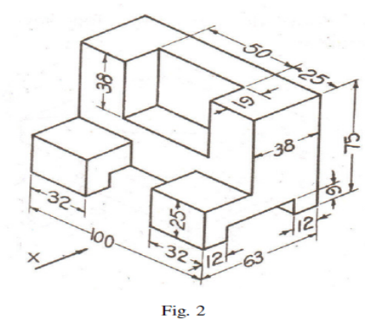 | L5 | CO5 | [14M]
6. |  | Frustum of a hexagonal pyramid of base edge 35 mm, edge of top face 20 mm and axis 70mm lies with base on HP and axis vertical. Draw its isometric projection. | L4 | CO6 | [14M]
7. |  | A pentagonal lamina having edge 40 mm is placed such that the perpendicular bisector of one of the edges is inclined at 30⁰ to HP and 45⁰ VP. Draw the top view and front views of the lamina. | L2 | CO1 | [14M]
8. | a) | What are the input and output devices used in CAD? | L2 | CO5 | [7M]
 | b) | Explain the various advantages and disadvantages of CAD. | L2 | CO6 | [7M]
-- 00 -- 00 –

